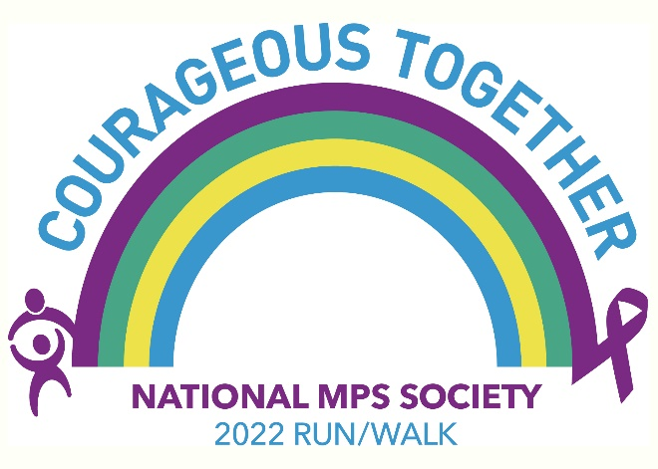
National MPS Society
Raleigh Run for Rare
MPS 5K & 1 Mile Walk
March 26, 2022 bit.ly/runforrare22

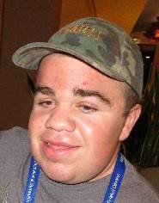
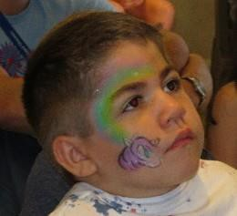
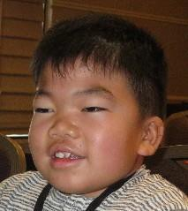
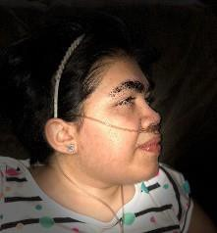

Please join the National MPS Society as we raise money to support MPS & ML research.

HELP US FIND A CURE!!! These pictured individuals and others like them are diagnosed with MPS or ML. These diseases are genetic lysosomal storage diseases (LSD) caused by the body’s inability to process waste properly due to enzyme deficiency. Normally, the body uses enzymes to break down and recycle materials in cells. In individuals with MPS or ML, the missing or insufficient enzyme prevents the proper recycling process, resulting in the storage of materials in virtually every cell of the body. As a result, cells do not perform properly and may cause progressive damage throughout the body, including the heart, bones, joints, respiratory system, and central nervous system.

While the disease may not be apparent at birth, signs and symptoms develop with age as more cells become damaged by the accumulation of cell materials. There is an estimate in the United States that 1 in 25,000 births result in MPS and 1 in 500,000 births will result in some form of ML. At the present time, there is no cure for this deadly disease; however, promising treatments and therapies are just around the corner. Money is needed to continue fund research to find a cure for MPS and ML.

The National MPS Society is a non-profit organization dedicated to improving the lives of children and families who are impacted by these genetic diseases and to help fund research for a cure. The Society is hosting a series of 5K Run/Walks across the country to raise money for research.

We are hosting the Raleigh Run for Rare 5K at Dorothea Dix Park in Raleigh, NC on March 26, 2022. For more information on this event please visit bit.ly/runforrare22.

Please join us to raise money for research and to spread awareness of these devastating diseases.

With Sincere Gratitude,
National MPS Society

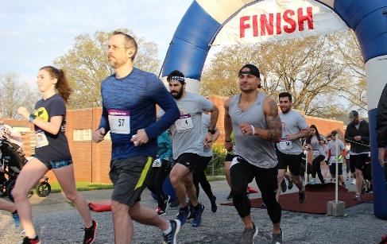

Raleigh Run for Rare

MPS 5K & 1 Mile Walk

Dorothea Dix Park
March 26, 2022

Corporate Sponsorship Choices

Corporate Sponsorship
Platinum Sponsor: $1,500.00: Corporate Name on T Shirt Back, Premium Logo, event/website sponsor recognition, banner presence at event, includes up to 25 participants
Gold Sponsor: $1,000.00: Corporate Name on T Shirt Back, Premium Logo, event/website sponsor recognition, small sign at the event, includes up to 25 participants

Team Sponsorship/Participation
Sign up a team of employees from your company to participate in the 5K Run/1 Mile Walk. One race registration form is enclosed. Please make copies for participants to complete to
Pre-register for the event.
Level 1: $500.00: up to 25 participants. Corp. Name on T Shirt Back plus event/website recognition
Level 2: $300.00: up to 15 participants. Corp. Name on T Shirt Back plus event/website recognition

Donation of Water/Food for Picnic
$500.00 donation: Corp. Name on T Shirt Back plus event/website recognition
$250.00 donation: Corp. Name on T Shirt Back plus event/website recognition
Less than $250.00 donation: Corporate Name – event/website recognition

For more information on the event:
bit.ly/runforrare22
- - - - - - - - - - - - - - - - - - - - - - - - - - - - - - - - - - - - - - - - - - - - - - - - - - - - - - - - - -

Yes, I would like to sign up as a sponsor or provide a donation for the picnic!
Company Name: Contact: Address: Phone Number:

Corporate Sponsorship | $1,500 | $1,000 | Other $
Team Sponsorship | $500 | $300 | Other $
Picnic Donation Item: Value $

Make Checks Payable to National MPS Society and mail to:
P.O. Box 14686, Durham, NC 27709.

The National MPS Society has been awarded a 4-Star Rating from Charity Navigator. The National MPS Society continuously receives 3 or 4 star ratings, meaning we outperform most charities for sound fiscal responsibility in the U.S.!

