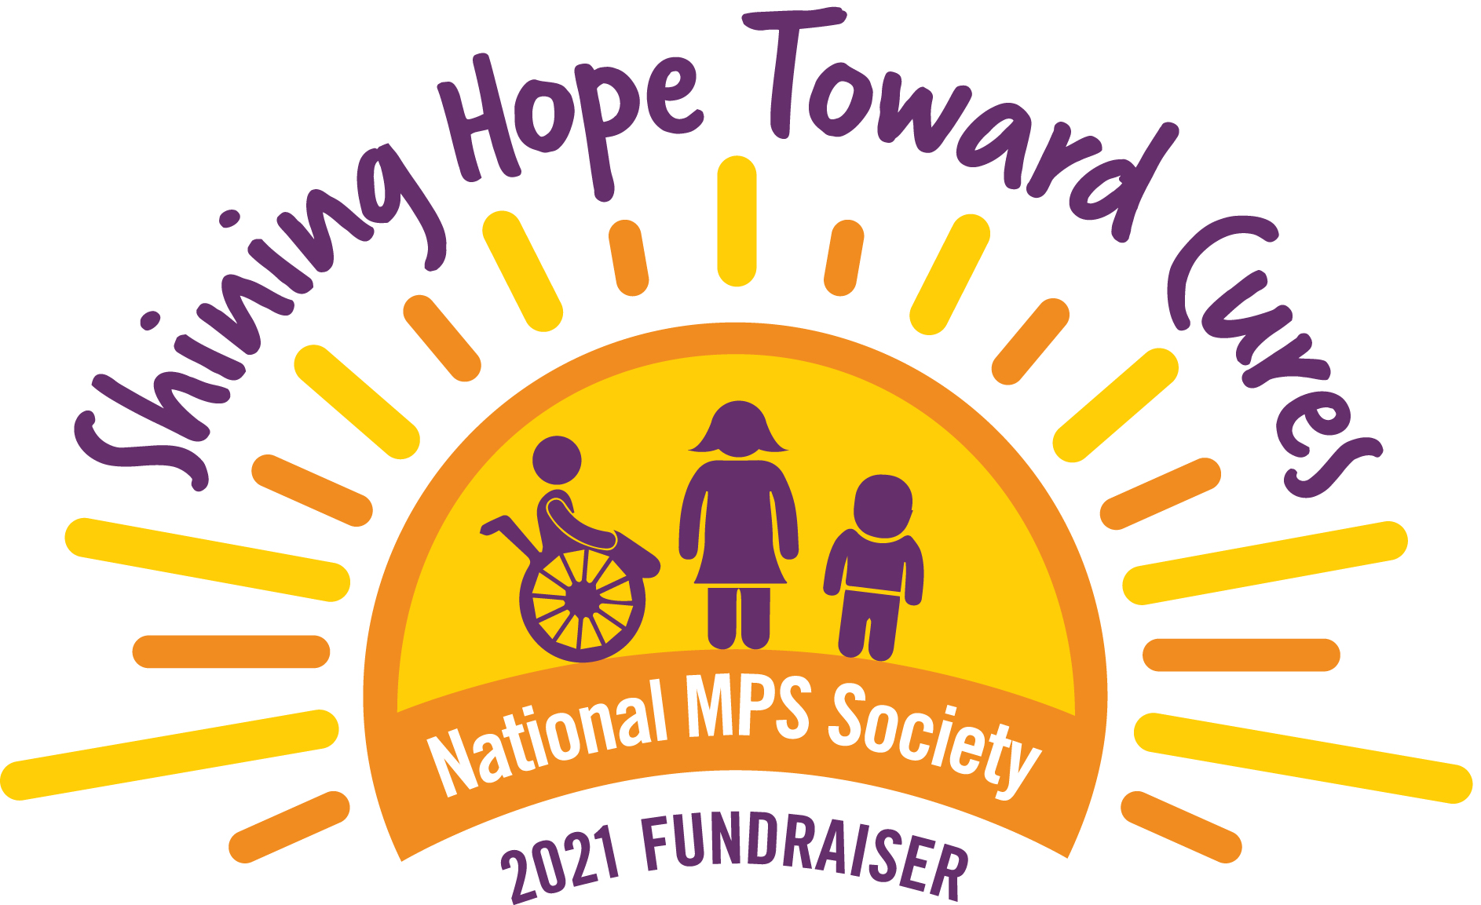National MPS Society
2021 Charity Golf Event
Enter Event Name Here

Name
Address
City, State, Zip

Dear XXXXXX:

Please join our family as we raise money to support MPS research.
Our XXX year-old child, ENTER Child’s Name has MPS enter type, which is a genetic lysosomal storage diseases (LSD) caused by the body’s inability to produce specific enzymes. Normally, the body uses enzymes to break down and recycle materials in cells. In individuals with MPS and related diseases, the missing or insufficient enzyme prevents the proper recycling process, resulting in the storage of materials in virtually every cell of the body. As a result, cells do not perform properly and may cause progressive damage throughout the body, including the heart, bones, joints, respiratory system and central nervous system.
While the disease may not be apparent at birth, signs and symptoms develop with age as more cells become damaged by the accumulation of cell materials. There is an estimate in the United States that 1 in 25,000 births will result in some form of MPS.
At the present time, there is no cure for this deadly disease. However, promising treatments and therapies are just around the corner. Money is needed to continue to fund the research to find a cure for MPS.

The National MPS Society is a non-profit organization dedicated to improving the lives of children and families who are impacted by these genetic diseases and to help fund research for a cure.

We are hosting Name of your walk/run Charity Golf Event on Date, in location of event. Our goal is to raise $XXX, 100% of which will go towards research to find a cure.

To reach our goal, we need your help.

Enclosed is information about the National MPS Society. (include brochure, tax letter etc)

If you are interested in sponsoring child’s name and/or event name and MPS, please complete the enclosed corporate sponsorship card and mail it with your donation to:
Your Name
Address
City, State Zip
Sincerely,
Your name
Your website if you have one
Attach a photo of your child if you wish
National MPS Society Federal Tax ID Number: 11-2734849

Add your walk/run info here**please note all $ amounts and options can be changed**
Corporate Sponsorship Choices
- Corporate Sponsorship
Platinum Sponsor: $1,500.00 . . . . .Corporate Name on T Shirt Back plus event/website sponsor recognition.
Gold Sponsor: $1,000.00 . . . . . . . . Corporate Name on T Shirt Back plus event/website sponsor recognition.

- Team Sponsorship/Participation

Sign up a team of employees from your company to participate in the 5K Run/1 Mile Walk. One race registration form is enclosed. Please make copies for participants to complete to
pre-register for the event.

$500.00 . . . for up to 50 participants. Corp. Name on T Shirt Back plus event/website recognition.
$250.00 . . . for up to 25 participants. Corp. Name on T Shirt Back plus event/website recognition.

- Donation of Merchandise for the Silent Auction & Raffle IF APPLICABLE

Accepting donations of gifts and/or merchandise to be sold at the silent auction or to be raffled off the day of the event.

$500.00 worth of merchandise . . . Corp. Name on T Shirt Back plus event/website recognition.
$250.00 worth of merchandise . . . Corp. Name on T Shirt Back plus event/website recognition.
Less than $250.00 worth of merchandise . . . Corporate Name – event/website recognition.

For more information on MPS:

www.yourwebsitehere.com www.mpssociety.org

- - - - - - - - - - - - - - - - - - - - - - - - - - - - - - - - - - - - - - - - - - - - - - - - - - - - - - - - - - - -
Yes, I would love to sign up as a sponsor!

Company Name: _______________________________________________________________
Contact: _______________________________________________________________________

Address:_______________________________________________________________________
PH # ____________________________

Corporate Sponsorship  $1,500 $1,000 $1 Other $___________

Team Sponsorship $500 $250 Other $___________

Merchandise Donation Item: ________________________ Value $___________

Make Checks Payable to National MPS Society and mail to: Your name, address, city, state, zip

