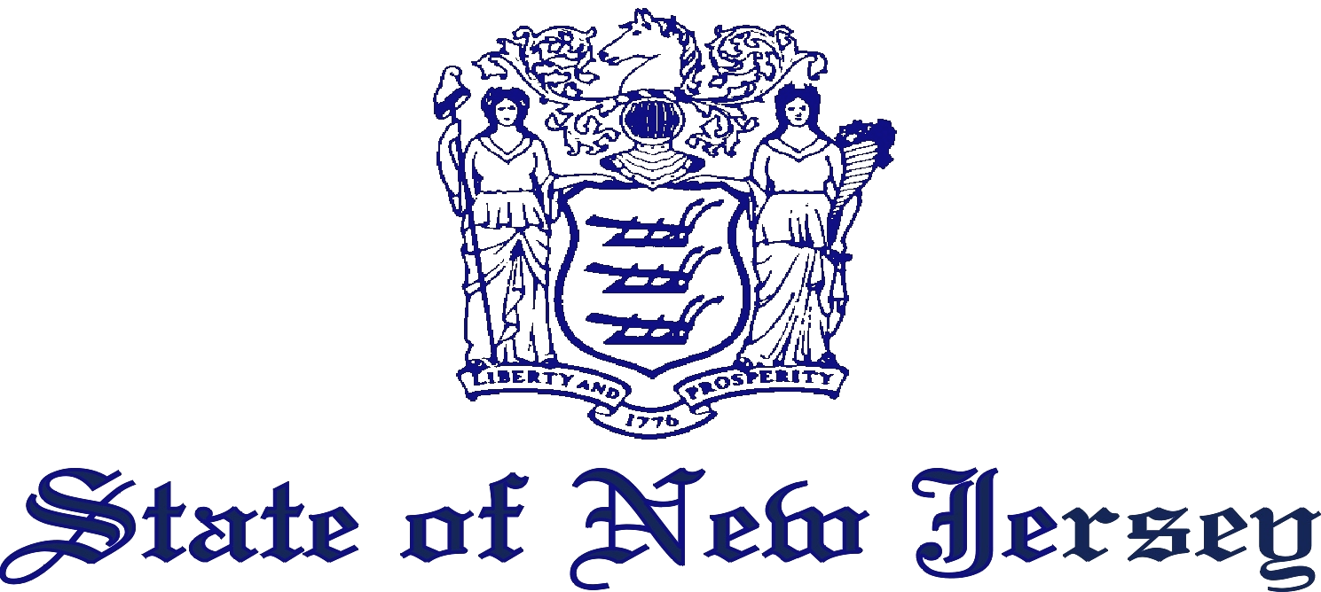

DEPARTMENT OF HEALTH
PO BOX 361
TRENTON, N.J. 08625-0361
www.nj.gov/health
Philip D. Murphy
Governor
Sheila Y. Oliver
Lt. Governor
Shereef M. Elnahal, MD, MBA Acting Commissioner

I hereby authorize the New Jersey Department of Health Newborn Screening Laboratory to release a sample of the residual dried blood spot specimen from my child’s newborn screening request form to:

_______________________________________________________
_______________________________________________________
_______________________________________________________
_______________________________________________________

Child’s Name: _______________________________

Date of Birth: _______________________________

Sex: Male / Female
(circle one)

Birth Mother’s Name: _______________________________

Birth Hospital: _______________________________

Birth City: _______________________________

Purpose of release: ___________________________________________________

_________________________________________________
Parent / Legal Guardian (print)

__________________________________________________
Parent / Legal Guardian (signature) Date

All release requests will be handled in accordance with Department policies

