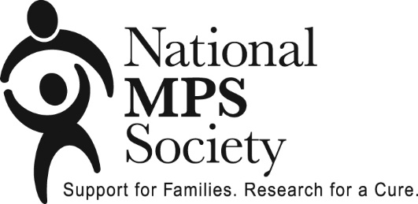
Medical Travel Assistance
Program Guidelines

Families may need to travel long distances to consult with medical professionals who are knowledgeable about MPS and ML. The Medical Travel Assistance Program (MTAP) helps fund out of town travel costs for such non-recurring medical appointments. MTAP may reimburse up to $750 in transportation costs and hotel expenses per affected individual per 12 month period for member families traveling to a medical appointment more than 200 miles from their home.

Reimbursable expenses include air, train, or bus fares, rental car, airport parking, and transportation to and from the medical facility or appropriate mileage at the current IRS rate for medical travel. Only coach airfares are eligible for reimbursement. A copy of the ticket invoice and other original transportation receipts are required for reimbursement. Hotel receipt must be submitted for reimbursement. Verification of attended medical appointment must be included. Please read program guidelines for complete details.

The MTAP is a three-step process. In Step 1, the applicant will submit an application to request funding for a future appointment. The Society will notify applicant if funding has been approved. In Step 2, the approved applicant will attend the medical appointment and have the verification form signed by the medical professional. In Step 3, the approved applicant will submit the completed reimbursement request and verification forms along with the transportation and/or hotel receipts to obtain reimbursement.

******************************************************************************

Program Guidelines

1) Only parents/legal guardians of an affected individual or an affected adult who reside in the United States and have active memberships are eligible for funds from MTAP.

2) Strictest confidentiality regarding application, names and funding will be maintained by the Society.

3) Reimbursement will be made available only for transportation and hotel expenses related to non-recurring medical appointments requiring travel more than 200 miles from your home. Expenses for routine medical appointments are not covered under MTAP. (e.g. travel expenses for weekly, monthly, or other ongoing treatments or therapies.)

4) Funding will be provided for the individual with MPS or ML and one parent/legal guardian or one travel companion.

4) The applicant must provide verification of attendance of the medical appointment by having the Verification Form signed by the treating medical professional.

5) Application for assistance should be made in advance of the appointment; however, special consideration may be provided in unusual circumstances where the cost has already been incurred.

MTAP Program Guidelines Continued

6) Grants for MTAP transportation and hotel assistance may be requested up to a maximum of $750.00 per affected individual per 12-month period, dependent on available funds. Multiple requests may be submitted, not to exceed $750.00 funded in a 12- month period.

7) The MTAP is a three-step process. In Step 1, the applicant will submit application to request funding for a future appointment. The Society will notify applicant if funding has been approved. In Step 2, the approved applicant will attend the medical appointment and have the verification form signed by the medical professional. In Step 3, the approved applicant will submit the completed reimbursement request and verification forms along with the transportation and/or hotel receipts to obtain reimbursement. Special consideration may be provided in unusual circumstances where the cost has already been incurred. If requested, up to 50% of approved funding may be reimbursed to member in advance of appointment travel.

8) Funding must be requested within 30 days of approved appointment date. If all required paperwork is not submitted within 30 days, the MTAP funding will be forfeited.

9) The Society will issue a letter to the applicant indicating whether the application has been approved or denied, and the amount of funding granted, if any.

Application Review

1) Application (Step 1) will be reviewed once all of the required documentation is received.

2) The Society will issue a letter to the applicant indicating whether the application has been approved or denied and the amount of funding granted, if any.
3) Reimbursement Request (Step 3) will be reviewed and funding made once all of the required documentation (Step 2 verification form signed by medical professional, Step 3 reimbursement request and receipts) are received. Funding request must be received within 30 days of appointment.
4) Payment will be mailed to the approved applicant.

5) In the event that funds budgeted for the current year are depleted, the MTAP will not accept additional applications that year. Applications will be accepted and reviewed after January 1 for appointments occurring in the new year.

