2009 Research Grants
All grant recipients were awarded $80,000 for the two year grant, with half of the total provided each year. Dr. Cosma received the MPS II grant, Drs. Esko and Fraldi received the MPS III grants, and Drs. Ponder and Simonaro received the general MPS research grants.
An additional $7,000 for mucolipidosis research will be provided as a partnership grant to ISMRD (International Society of Mannosidosis and Related Diseases). In support of the Lysosomal Disease Networks NIH grant research goals, the Society will fund $25,000 for the Neuroimaging Core which will benefit the four MPS projects.
Dr. Maria Pia Cosma
TIGEM, Naples, Italy
AAV2/5CMV-IDS therapy in MPSII mice: correction of CNS defects through IDS
delivery across the blood-brain barrier.
Children affected by mucopolysaccharidosis type II (MPSII; Hunter syndrome) lack the activity of the enzyme iduronate 2-sulfatase (IDS). They accumulate compounds in their body that gradually kill their cells and damage all of their visceral organs. A gene therapy approach was initiated to treat this central nervous system (CNS) disease in a mouse model of MPSII. Affected pups were injected with viral particles that targeted all of the visceral tissues. High levels of active IDS were produced, secreted into the plasma and also taken up by the brain. This approach gave important results, as the mice were cured of their visceral organ defects, and surprisingly, they also showed amelioration of the CNS phenotype. We now plan to extend this approach to adult and juvenile MPSII mice and to more specifically study how the IDS enzyme reaches the brain, in terms of its crossing of the blood-brain barrier, which was thought not to be permeable to high molecular weight proteins, such as the IDS. We plan to carry out these studies with a variety of different approaches. If successful, our studies should allow us to set up more efficient treatments for the cure of the CNS phenotype of patients with Hunter syndrome.
Dr. Jeffrey Esko
University of California, San Diego, CA
Substrate reduction strategy for MPS IIIA
Mucopolysaccharidoses (MPS) are inherited metabolic disorders in which cellular polysaccharides (glycosaminoglycans) can no longer be degraded, causing aberrant storage of partially degraded material in lysosomes. Children born with these diseases exhibit developmental abnormalities, organ failure and mental retardation, defects that often result in death within the first few decades of life. A subset of MPS diseases result from enzyme deficiencies required by cells to degrade a class of glycosaminoglycans known as heparan sulfate. This research proposal will test if altering heparan sulfate biosynthesis is an effective method of preventing its accumulation in one of these diseases, specifically MPSIIIA. The approach consists of genetically disrupting heparan sulfate biosynthesis in MPSIIIA patient cell lines and mouse models. Its efficacy will be assayed by reduction of lysosomal storage and restoration of normal cellular turnover of glycosaminoglycans. Positive results would justify and encourage the development of small molecule inhibitors of heparan sulfate biosynthesis as a way to accomplish substrate reduction therapy in patients. The major advantage of substrate reduction is that these agents might access the brain where glycosaminoglycan storage is highly detrimental and existing therapies appear ineffective
Dr. Alessandro Fraldi
TIGEM, Naples, Italy
Developing a systemic AAV-mediated gene therapy to cross the blood-brain barrier and treat the brain pathology in MPS IIIA
Mucopolysaccharidosis type IIIA (MPS-IIIA) is an inherited disease caused by the deficiency of sulfamidase (SGSH), a gene that encode an enzyme needed for the degradation of a large macromolecule called heparan sulfate. As consequence, such substrate accumulates in the cells and tissues of the affected patients causing cell damage. The central nervous system is the predominant target of damage and in fact, the MPS-IIIA patients experience severe mental retardation and neuropathological decline that ultimately leads to death. Gene therapy is a therapeutic option for several inherited diseases. The aim of gene therapy is to substitute the defective gene with a functional one. Often a modified not-pathogenic virus is used as vehicle to transport the gene in the affected tissues. In this study we will test the efficacy of a therapeutic approach based on the delivery, via intravenous injection, of an adeno-associated virus (AAV) bearing a functional SGSH. The AAV have a tropism for the liver, so that upon injection the virus will reach the liver that consequently will produce the functional SGSH. The functional SGSH will be then secreted from the liver and will enter into the brain throughout the blood torrent. Importantly, the SGSH will be opportunely modified to be secreted more efficiently from the liver and to make it able to efficiently pass the blood-brain barrier and transduce the brain.
Dr. Katherine Ponder
Washington University, St. Louis, MO
The role of cathepsin K in cardiac valve disease in MPS
Mucopolysaccharidosis (MPS) is due to a genetic deficiency in the activity of an enzyme that degrades glycosaminoglycans. One of the serious manifestations of MPS is the development of heart disease, which can result in reduced delivery of oxygenated blood to the body and require surgery to replace the valve. This can involve thickened heart valves that block the flow of blood into the heart. Heart valves can also be leaky, which allows blood to flow in the wrong direction. The goal of this project is to understand what causes heart valves problems, and to identify a therapy to prevent these heart valve abnormalities from developing. Collagen is the major protein that provides strength to the heart valves. We have found that the amount of collagen is markedly reduced in heart valves of MPS I and MPS VII dogs, and propose that this is what weakens the valve. We hypothesize that reduced amounts of collagen are due to abnormally high levels of an enzyme that can degrade collagen, cathepsin K. It that is the case, it might be possible to prevent heart valve disease with inhibitors of cathepsin K that are currently being used to treat osteoporosis. This project may identify a drug to prevent the development of heart valve disease in MPS.
Dr. Calogera Simonaro
Mount Sinai School of Medicine, New York, NY
Novel anti-inflammatory therapies for the mucopolysaccharidoses
Enzyme replacement therapy (ERT) is currently available for three MPS diseases, although the effects of this therapy on bone and cartilage are very limited. Thus, new treatment approaches are clearly needed, alone or as adjuncts to ERT. Our research will use animal models to explore such new therapies. In particular, we will comprehensively evaluate the bones and joints of MPS VI animals treated with the FDA-approved anti-inflammatory drug, Remicade. This drug targets the inflammatory pathway we have found to be activated in MPS patients (TLR4). Our results to date have shown that Remicade can substantially reverse or prevent inflammation in MPS VI rats, and we now plan to comprehensively evaluate the bones and joints in animals treated with Remicade alone or in conjunction with ERT (Naglazyme). Since Remicade is currently FDA-approved for the treatment of arthritis and other inflammatory diseases, we are hopeful that completion of these animal studies will lead to clinical trials and approval for MPS patients. We will also complete the analysis of an important proof of principle experiment in which the TLR4 inflammatory pathway is inactivated in MPS VII mice. These results will provide the basis for the continued development of anti-inflammatory treatment strategies for MPS VI and other MPS disorders, and identify new molecular targets for drug therapy.

1st Year Research Reviews – 2009
Dr. Sara Cathey One year Partnership Grant with ISMRD
Greenwood Genetic Center, North Charleston, SC
Natural history study for mucolipidosis
In 2008 and 2009 Partnership Grants with ISMRD supported natural history studies of Mucolipidosis (ML) II and ML III. The ML Project of the Greenwood Genetic Center (GGC) is an ongoing effort to understand the disease course in people affected by these rare conditions. Fourteen individuals with ML II or III and their families participated in GGCs Second ML Clinic, held July 27-29, 2009 at the South Carolina Center for the Treatment of Genetic Disorders in Greenwood, South Carolina. During this special clinic, participants were evaluated by clinical geneticists, psychologists, an orthopedic surgeon, and an ophthalmologist. All patients had skeletal x-rays to evaluate the progression of bone disease. Many patients (and their parents!) provided samples for laboratory studies. Most of these same patients participated in the first ML Clinic held in 2006 at GGC. ML affects people from around the world, and each patient can contribute to better understanding. The natural history study went international in November 2009 when ML patients from Australia and New Zealand participated in special clinics held in Sydney, Australia and Wellington, New Zealand.
The ML Project has had a positive impact in many ways, including important contributions to the medical literature about ML. Large collections of clinical and laboratory data have been established. Samples collected are used by scientists at GGC and researchers around the world. Patients and their doctors have another source of information and support. Following a group of patients with this rare disease over time lets us learn the natural history of the illness, evaluate the usefulness of potential therapies, and set sights on effective treatments. To conquer the illness we have to learn about the people affected by ML.
Lysosomal Disease Network, one year grant
University of Minnesota, Minneapolis, MN
Neuroimaging Core activities of the projects of the LDN grant during the first year of work
Progress Report for MPS Society Award
This award is being used to support the Neuroimaging Core of the Lysosomal Disease Network, specifically the work of Dr. Alia Ahmed in volumetric neuroimaging (about 50% of her salary). The award thus supports the following LDN studies, all of whom employ neuroimaging:
- Longitudinal Study Project 1 (Shapiro, PI Longitudinal Studies of Brain Structure and Function in MPS Disorders (MPS I, II, and VI),
- Longitudinal Study Project 2 ( Polgreen PI, Longitudinal study of bone disease and the impact of growth hormone treatment in MPS I, II, and VI).
- Pilot Study Project 16, (Potegal PI, Characterizing the Neurobehavioral Phenotype in MPS III.
- Pilot Study Project 12 (Dickson PI, Intrathecal ERT for Cognitive Decline in MPS I.
The neuroimaging core has four functions, 1) to collect imaging data in a comparable manner suitable for natural history determination, 2) Develop and validate disease specific standardized imaging protocols, semi-quantitative MRI clinical ratings scales, and formal quantitative measures to be used as biomarkers for natural history and clinical trials, 3) demonstrate that standardized protocols will identify optimal imaging sequences, appropriate intervals for follow-up, and best clinical practices, 4) archives of scans for educational purposes. Dr. Ahmed’s work supports items 2 and 3.
With regard to optimal imaging seqences, protocols have been established by our neuroimaging core for volumetric analysis. For quantitative volumetric analysis of scans, we have established methods for reliable determination of hippocampus and amygdala using a three dimensional manual tracing program called BRAINS2. Dr. Alia Ahmed is expert at this demanding task.
Prior to funding, to develop her skills, she became proficient in tracing on 10 hippocampi of tremor patients and 5 caudates of normal subjects, using ImageJ, a two dimensional program. We decided to change to BRAINS2, which is a three dimensional program allowing tracing on coronal, saggital, and axial images which can be then combined to produce a structural image. To trace the hippocampus for each patient, she traced one image in a saggittal section and two in a coronal section, one with and one without white matter. Thus for each brain scan she traces each (left and right) hippocampus 3 times, making 6 tracings. For the amygdala, which also requires manual tracing, for each brain scan she does one sagital and one coronal tracing of the left and of the right amygdala.
So far to trace the hippocampus, she has traced 42 MPS I brain scans, 9 MPS II, 10 MPS III, 7 MPS VI, 2 MPS VII , and 9 control brain scans ( Total 79 brains scans X 6 tracings = 474). For the amygdala, she has traced 16 brains (we are only doing it for MPS II and III) totaling 64 tracings. She has also traced the caudate in 13 patients totaling 26 tracings.
Thus, in summary, Dr. Ahmed has successfully traced hippocampus on 70 brains of MPS children and 9 controls and has successfully traced the amygdala in 16 patients. These tracings can be seen in three dimensional space and we are anticipating that we can evaluate changes in configuration as well as volume over time. We are comparing some of Dr. Ahmed’s tracings to an automated program called FreeSurfer which is implemented at the Minnesota Supercomputer Center (they have provided a grant to cover our costs). She also did intra rater reliability studies on ten brain scans (rating each one twice) and now is working on inter rater reliability studies (comparing her ratings with those of Dr. Nestrasil, our expert in image acquisition and other methods of image analysis. Thus far, excellent manual tracing reliabilities on MPS I patients and preliminary data on brain volumes in 18 MPS I patients and 9 MPS II patients have been obtained. The results of the reliability study were presented at the WORLD symposium in February; this presentation is now being written for publication. It is attached to this progress report as well as the volumetric comparisons of attenuated MPS I and MPS II.
In addition, clinical ratings scales (such as the Matheus scale for MPS disorders) are now being refined to increase their reliability. Dr. Ahmed is also carrying out this analysis together with a member of our radiology department to determine its reliability and to determine if we can improve its sensitivity.
With respect to her involvement in the four studies: she has analyzed brains for 40 children in the Shapiro study, 25 for the Polgreen study (overlaps with Shapiro study), 10 for the Potegal study, and 3 for the Dickson study.
Funds have been used for 1) Dr. Ahmed’s salary, 2) a computer for her image analysis, and 3) travel for meetings and training.
Abstract:
Ahmed, A., Nestrasil, I., Rudser, K,, Shapiro, E. Reliability of manual and automated tracing of hippocampal volumes in MPS patients and normal controls: A report of the neuroimaging core of the lysosomal disease network. Molecular Genetics and Metabolism, 99 (2); 2010, S9.
Dr. Maria Pia Cosma
TIGEM, Naples, Italy
AAV2/5CMV-IDS therapy in MPSII mice: correction of CNS defects through IDS
delivery across the blood-brain barrier.
Results funded by the MPS society have been published in the following paper:
Polito V and Cosma MP (2009). IDS crossing of the blood-brain barrier corrects CNS defects in MPSII mice. AJHG 85(2):296-301.
Abstract
Mucopolysaccharidosis type II (MPSII), or Hunter syndrome, arises from a deficiency in iduronate 2-sulfatase (IDS), and it is characterized by progressive somatic and neurological involvement. The MPSII mouse model reproduces the features of MPSII patients. Systemic administration of the AAV2/5CMV-hIDS vector in MPSII mouse pups results in the full correction of glycosaminoglycan (GAG) accumulation in visceral organs and in the rescue of the defects and GAG accumulation in the central nervous system (CNS). Remarkably, in treated MPSII animals, this CNS correction arises from the crossing of the blood-brain barrier by the IDS enzyme itself, not from the brain transduction. Thus, we show here that early treatment of MPSII mice with one systemic injection of AAV2/5CMV-hIDS results in prolonged and high levels of circulating IDS that can efficiently and simultaneously rescue both visceral and CNS defects for up to 18 months after therapy.
We are now testing if the treatment of the CNS defects can be also achieved in juvenile and adult MPSII mice. For that we injected groups of ids-/y animals with AAV2/5CMV-IDS viral particles. We are evaluating the IDS activities in the plasma and GAG contents in the urines to monitor the efficiency of the therapy. In addition the mice were tested with rotarod tests which evaluate the sensorimotor coordination. Indeed, we have truly characterized groups of ids-/y mice at different ages and found that Purkynje cells in the cerebellum strongly degenerate through the progression of the disease. Thus we are testing the rescue of the cerebellum defects after the therapy.
In addition to these gene therapy experiments we are also setting up enzyme replacement protocols to treat simultaneously the visceral defects and the CNS features of the MPSII mice. We are developing efficient protocols that allow the IDS to cross the blood brain barrier, to correct CNS phenotype and to reverse neurobehavioural features.
Dr. Jeffrey Esko
University of California, San Diego, CA
Substrate reduction strategy for MPS IIIA
The original focus of this grant was to demonstrate that substrate reduction would prove effective as a treatment for Sanfiippo syndromes. We found that reducing the level of reduced heparan sulfate biosynthesis in MPSIIIa fibroblasts by ~40% diminished lysosomal storage by ~50%. These studies are limited to short-term experiments because of the way that we silenced the expression of certain genes in the system. To get at this question in vivo, we have crossed the MPSIIIa mouse with mice carrying mutations in genes involved in heparan sulfate biosynthesis. The objective is to test the impact of substrate reduction on lysosomal storage and pathology in specific cell types in vivo, specifically hepatocytes, astrocytes, neurons and macrophages. We should have our first results in the next 6 months.
We also found that MPSIIIa cells (as well as MPSIIIb, MPSIIIc, and MPSIIId cells) store a significant amount of chondroitin/dermatan sulfate in addition to heparan sulfate. This finding was unexpected since the primary genetic defects in Sanfilippo syndrome are in enzymes specifically involved in heparan sulfate biosynthesis. Enzyme replacement therapy using recombinant sulfamidase, the enzyme missing in MPSIIIa, resolved both the primary and secondary storage (Fig. 1), suggesting that the accumulation of heparan sulfate caused the secondary storage of chondroitin/dermatan sulfate.
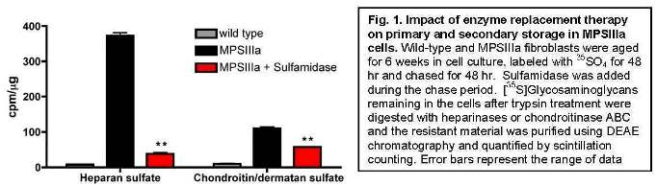
To understand the cause of secondary storage, we assessed whether heparan sulfate inhibited enzymes involved in chondroitin/dermatan sulfate degradation. We found that heparin and heparan sulfate strongly inhibited the enzyme iduronate-2-sulfatase (IC50 values of ~3 ?g/mL and ~14 ?g/mL, respectively). We are currently testing whether supplementing iduronate-2-sulfatase can reduce secondary storage and whether strategies that reduce both primary and secondary substrate accumulation are more effective at treating lysosomal storage.
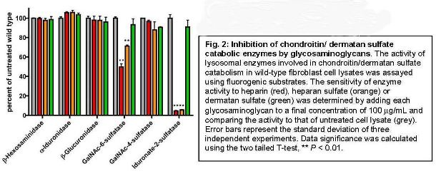

Dr. Alessandro Fraldi
TIGEM, Naples, Italy
Developing a systemic AAV-mediated gene therapy to cross the blood-brain barrier and treat the brain pathology in MPS IIIA
The aim of this project is to develop a low-invasive systemic gene therapy strategy based on the intravenous injection of AAV serotype 8. This serotype displays high tropism to the liver and will be used to delivery of an engineered gene encoding a chimeric modified sulfamidase optimized to be: (i) highly secreted from the liver thus reaching high levels of circulatingenzyme in the blood stream; (ii) to efficiently cross the BBB.
Construction and validation of the engineered sulfamidase
In order to increase sulfamidase secretion from the liver and thus the amount of the enzyme in the blood stream available to specifically target the brain, we engineered the sulfamidase by replacing its own signal peptide (SP) with an alternative one. Two signal peptides have been tested, the Iduronate-2-sulfatase (IDS) signal peptide and the human antitrypsin (AAT) signal peptide. The rationale behind the use of these two signal peptides is that IDS is a lysosomal enzyme that has been demonstrated to be secreted at high levels from the liver while the AAT is a highly secreted enzyme. To test the functionality of chimeric sulfamidase coding sequences containing either the IDS-SP or the AAT-SP we transfected the constructs in Hela and MEF cells derived from MPS-IIIA mice; as control, the cells were also transfected with not-engineered SGSH enzyme. Two days after transfection we measured the SGSH activity in the pellet and in conditioned medium of transfected cells. In the cells transfected with either hAAT(SP)-SGSH-Flag or IDS(SP)-SGSH-Flag, the level of sulfamidase protein detected in the pellet and the medium was increased compared to the level detected in control cells (transfected with the not-engineered sulfamidase) (Fig.1). Such an increase in sulfamidase protein levels was due to both increased efficiency in secretion (medium/total activity; see graph on the right of figure 2) and increased stability of engineered sulfamidase (Fig.1). The analysis of SGSH activity in MEF cells derived from MPSIIIA mice confirmed the results obtained in the Hela cells (not shown).

Engineering the final chimeric sulfamidase. The final goal of our project is to product a modified sulfamidase capable to cross the BBB and target the CNS via receptor-mediated transcytosis. For this reason before starting the experiments aimed at evaluating the therapeutic efficacy of the substituting SP signal in SGSH, we further engineered the modified SGSH with a specific brain-targeting protein domain, the Low Density Lipoprotein receptor (LDLR)-binding domain of the Apolipoprotein B (ApoB LDLR-BD) (Fig.3). The Binding Domain of ApoB will allow the sulfamidase to reach the brain cells by binding LDL receptors, which are abundant on the endothelial cells of BBB. The two final engineered sulfamidase constructs comprise at C-terminal the ApoB LDLR-BD and at N-terminal either an IDS or an hAAT signal peptide (IDSsp-SGSHflag-ApoB and hAATsp-SGSHflag-ApoB) (Fig. 3). To evaluate the functionality of IDSsp-SGSHflag-ApoB and hAATsp-SGSHflag- ApoB we transfected MPSIIIA MEF cells with these final constructs and compared the outcomes with those resulting from the transfections with partial modified (hAATsp-SGSHFlag, IDSsp-SGSH-Flag) and not modified SGSH constructs. Surprisingly, we observed that SGSH activity in the pellet and in the conditioned medium was higher in the cells transfected with the final chimeric constructs compared with the activity measured in the cells transfected with the other constructs, indicating that final engineered sulfamidase were efficiently secreted and even more stable compared to partial engineered sulfamidase (Fig.4). These results were associated with a higher secretion efficiency of the final engineered sulfamidase enzymes with respect to not-engineered sulfamidase. The secretion efficiency of the final chimeric constructs was similar to that measured after transfection of partial chimeric sulfamidase (containing only the alternative signal peptide).
In conclusion these results demonstrate that: (i) the chimeric sulfamidase enzymes containing the alternative signal peptide are functional and active; (ii) they are more stable with respect to not-modified sulfamidase; (iii) they are secreted with increased efficiency compared to not engineered sulfamidase enzyme; (iv) the introduction of the ApoB LDLR-BD to produce the final engineered sulfamidase did not affect neither the functionality nor the increased secretion efficiency observed in the cells transfected with the partial engineered sulfamidase.
In addition, the final engineered constructs appear to be more stable compared to partial engineered constructs.
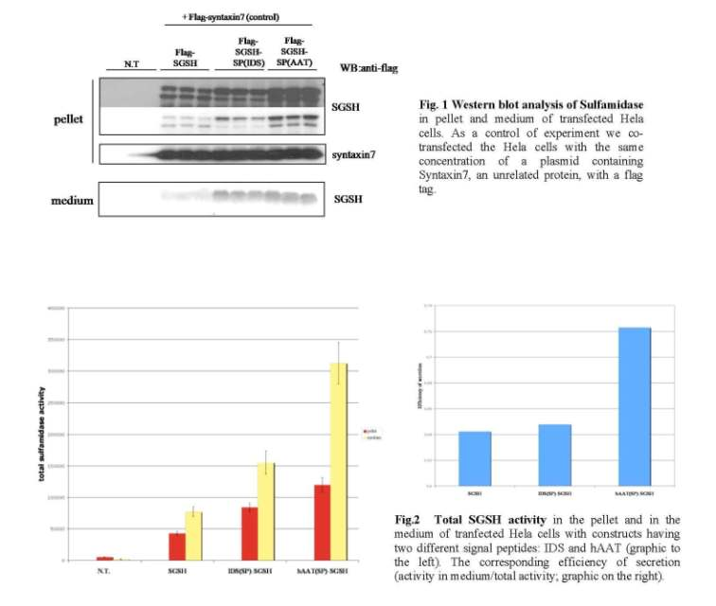

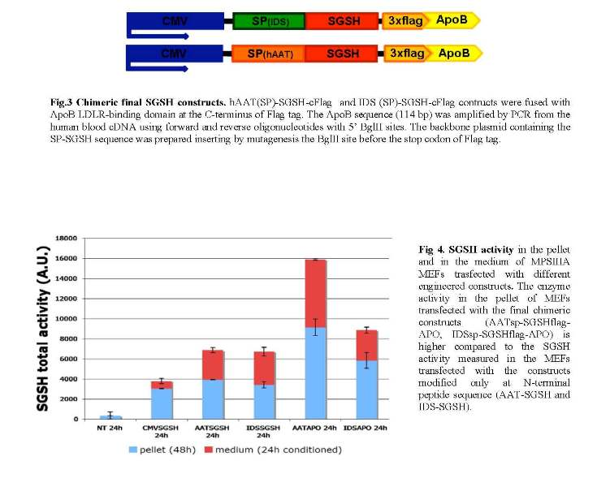

Preliminary in vivo results in MPS IIIA mice injected with final engineered sulfamidase
We obtained very preliminary but extremely encouraging results in MPS-IIIA injected with the final constructs hAATsp-SGSHflag-ApoB. Adult MPS-IIIA mice were systemically injected with AAV2/8-TBG- hAATsp-SGSHflag-ApoB (the TBG is a liver specific promoter). A group of MPS-IIIA were also injected with AAV2/8-TBG-SGSH (containing the not modified sulfamidase) as control. The mice were sacrificed one month after injection. In the mice injected with the chimeric sulfamidase we observed higher liver sulfamidase activity and a very strong increase in the sulfamidase secretion respect to control mice. Moreover, we detected a significant increase in SGSH activity into the brain of mice injected with the chimeric sulfamidase. We are now evaluating the effective cross of BBB by the chimeric sulfamidase. As planned in the proposal, we have also designed an in vivo large study aimed to evaluate the rescue of pathological phenotype in MPS-IIIA. We plan to complete this study within one year.

Dr. Katherine Ponder
Washington University, St. Louis, MO
The role of cathepsin K in cardiac valve disease in MPS
Mucopolysaccharidosis (MPS) is due to a genetic deficiency in the activity of an enzyme that degrades glycosaminoglycans. One of the serious manifestations of MPS is the development of heart disease, which can result in reduced delivery of oxygenated blood to the body. This can involve thickened heart valves that block the flow of blood, and/or heart valves that are leaky and allow blood to flow in the wrong direction. The goal of this project is to understand what causes heart valve problems, which may ultimately allow us to identify a therapy to prevent these heart valve abnormalities from developing.
I. Evaluate collagen and elastin in the extracellular matrix (ECM) of mitral valves, chordae tendineae, and aortic valves in MPS I and MPS VII dogs by light and electron microscopy
The goal of this aim is to determine if collagen and elastin structure are abnormal in heart valve tissues using histochemical techniques. Collagen is the major extracellular matrix protein of the heart valves. We have demonstrated that the amount of structurally-intact collagen in the mitral valve is approximately 2% of normal at 2 years of age in MPS VII dogs, and that neonatal gene therapy with a retroviral vector can improve the collagen structure. This is consistent with the hypothesis that abnormal collagen structure is responsible for the abnormal valve function. The aortic valves and chordae tendinae have some reduction in structurally intact collagen, but this is less severe. We are in the process of quantifying these results at various ages in different treatment groups.
II. Determine if RNA for cathepsin K or other genes involved in ECM assembly or degradation are upregulated in the mitral valves, chordae tendineae, and aortic valves in MPS VII dogs
Abnormal collagen structure could reflect a failure to synthesize or assemble collagen or elastin properly, or an increase in expression of enzymes with collagenase activity. Mitral valves, chordae tendineae, and aortic valves have been isolated from normal, MPS VII, and retroviral vector-treated MPS VII dogs at 6 months of age, when collagen fragmentation is apparent in untreated MPS VII dogs, and expression of several genes from the mitral valve have been evaluated. Cathepsins and matrix metalloproteinases (MMP) are enzymes that can degrade collagen. RNA analysis demonstrated that cathepsin B, S, and W, and MMP 8, 9, and 12 were markedly upregulated (10- to 100-fold) in the mitral valves of untreated MPS VII dogs. Although cathepsin K RNA was not significantly elevated, several of the other cathepsins and the MMPs have collagen-degrading activity. We are in the process of using microarray analysis to look for changes in expression of other genes that are involved in collagen assembly or degradation, and evaluating the signal transduction pathways that may be involved. This may identify targets that can be inhibited in order to reduce collagen abnormalities.
III. Evaluate enzyme activities and GAG levels in the mitral valves, chordae tendineae, and aortic valves in MPS VII dogs
The final aim of this project will evaluate extracts from the mitral valves, chordae tendineae, and aortic valves of normal, MPS VII, and RV-treated MPS VII dogs for several biochemical parameters. Homogenized samples have been tested and found to have markedly elevated cathepsin activities, although the specific cathepsins that are involved are still being evaluated, and MMP activities have not yet been tested. These data further substantiate our hypothesis that increases in cathepsin activities contribute to abnormal collagen structure,
although additional assays still need to be performed.
Dr. Calogera Simonaro
Mount Sinai School of Medicine, New York, NY
Novel anti-inflammatory therapies for the mucopolysaccharidoses
Current therapeutic strategies for the MPS disorders, including enzyme replacement therapy (ERT), have limited effects on the bones and joints. The premise of our research is that new and improved treatment approaches are necessary for these disorders, and that this is best achieved by an improved understanding of the underlying pathogenic mechanisms. Our recent research has focused on the involvement of the toll-like receptor 4 (TLR4) signaling (inflammatory) pathway in MPS bone and joint disease, and the use of anti-inflammatory agents for the treatment of these diseases. The most recent studies were published in the Proceedings from the National Academy of Sciences (Simonaro et al., Proc Natl Acad Sci USA. 2010 Jan 5;107(1):222-7), and will be summarized below.
TLR4 knockout (KO) mice were bred to MPS type VII mice. Inactivation of this proinflammatory pathway in double KO mice corrected many biochemical and clinical features of the MPS disease, suggesting that drugs targeting this pathway could be effective in the treatment of these disorders. Double KO animals grew substantially better than MPS VII mice alone, and had longer and thinner bones. The levels of several inflammatory cytokines, including TNF-?, also were substantially reduced in the double KO mice, leading us to evaluate the effects of the FDA-approved anti-TNF-? drug, RemicadeTM, in MPS VI rats. When initiated pre-symptomatically, intravenous RemicadeTM treatment prevented the elevation of TNF-? and other inflammatory molecules in the blood. Importantly, the levels of these markers also were markedly reduced in cartilage (chondrocytes) and synovial membranes of the treated animals. Although the overall growth of these animals was not improved by RemicadeTM treatment, the number of apoptotic or dead chondrocytes were reduced by ~50%, as was the infiltration of synovial tissue into the underlying bone. These results indicated positive effects of RemicadeTM treatment at the sites of pathology. RemicadeTM treatment also reversed the established inflammatory disease in older animals. Thus, these studies revealed the important role of TLR4 signaling in the pathogenesis of MPS bone and joint disease, and suggested that targeting a downstream mediator of this pathway, TNF-?, might have a positive effect in attenuating the inflammatory response in MPS. This could lead to improved joint/bone pathology and also increase the accessibility of synovial tissues to recombinant proteins, thus improving the efficacy of ERT.
Towards this end, we have recently finished our combination studies in the MPS VI rats with RemicadeTM and ERT (NaglazymeTM), and are in the process of performing a comprehensive evaluation of the effects on the bone and joint disease. We hope that these studies will provide essential data that might fast-track this therapy into the clinic to be evaluated in MPS patients.

2nd Year Research Reviews – 2009
MPS II
Dr. Maria Pia Cosma
TIGEM, Naples, Italy
AAV2/5CMV-IDS therapy in MPSII mice: correction of CNS defects through IDS delivery across the blood-brain barrier
Results funded by the MPS society have been published in the following paper:
Correction of CNS defects in the MPSII mouse model via systemic enzyme replacement therapy.
Polito VA, Abbondante S, Polishchuk RS, Nusco E, Salvia R and Cosma MP. Human Molecular Genetics 2010, Vol 19, No 24.
Mucopolysaccharidosis type II (MPSII), or Hunter syndrome, is a devastating disorder associated with a shortened life expectancy. Patients affected by MPSII have a variety of symptoms that affect all organs of the body and may include progressive cognitive impairment. MPSII is due to inactivity of the enzyme iduronate-2-sulfatase (IDS), which results in the accumulation of storage material in the lysosomes, such as dermatan and heparan sulfates, with consequent cell degeneration in all tissues including, in the severe phenotype, neuro- degeneration in the central nervous system (CNS). To date, the only treatment available is systemic infusion of IDS, which ameliorates exclusively certain visceral defects. Therefore, it is important to simultaneously treat the visceral and CNS defects of the MPSII patients. Here, we have developed enzyme replacement therapy (ERT) protocols in a mouse model that allow the IDS to reach the brain, with the substantial correction of the CNS phenotype and of the neurobehavioral features. Treatments were beneficial even in adult and old MPSII mice, using relatively low doses of infused IDS over long intervals. This study demonstrates that CNS defects of MPSII mice can be treated by systemic ERT, providing the potential for development of an effective treatment for MPSII patients.
MPS III
Dr. Jeffrey D. Esko
University of California, San Diego, CA
Substrate Reduction Strategy for MPS IIIA
The original focus of this grant was to demonstrate whether substrate reduction would prove effective as a treatment for Sanfiippo syndromes. As outlined in our progress report 2010, siRNA knock down of the heparan sulfate biosynthetic gene EXT1 in human MPSIIIa fibroblasts is able to diminish lysosomal storage by ~50% ex vivo. To test substrate reduction therapy in vivo, we have crossed MPSIIIa (Sgsh-/-) mice onto an Ext1+/- background. As shown in figure 1a, Ext1 heterozygosity reduced heparan sulfate chain length by ~25% in mouse embryonic fibroblasts (MEFs) isolated from these mice. This reduction in the amount of cell surface heparan sulfate was sufficient to normalize turnover by ~30% (Fig. 1b), demonstrating the efficacy of this substrate reduction therapy approach.

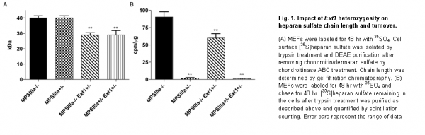

Currently we are quantifying the amount of heparan sulfate in the tissues ofSgsh^{-/-} mice that are heterozygous forExt1 using mass spectrometry to determine the impact of substrate reduction therapy in different tissues. In addition, the histological markers GFAP and Ubiquitin are being used to determine the impact of substrate reduction on astrocytosis and aberrant autophagy in the brain, respectively. To complement these studies we are also breeding MPSIIIa mice heterozygous for bothExt1 andExt2. Double heterozygosity should result in heparan sulfate chains even shorter than those observed inExt1heterozygotes and may have a greater impact on lysosomal storage and pathology. These studies should be completed in the next 3 – 6 months.
In addition to its ability to reduce lysosomal storage, we hypothesized that substrate reduction therapy may serve as a cost effective way to increase the effectiveness of enzyme replacement therapy. To test this, we compared the dose of recombinant sulfamidase necessary to normalize heparan sulfate turnover in MEFs derived fromSgsh^{-/-} orSgsh^{-/-};Ext1^{+/-} mice. Importantly, the effective dose (ED₅₀) was improved by more than 2- fold in MPSIIIa MEFs heterozygous forExt1, suggesting that combined substrate reduction therapy and enzyme replacement therapy may provide a more efficient approach to treating Sanfilippo disease. To determine the impact ofExt heterozygosity on the sensitivity ofSgsh^{-/-} mice to enzyme replacement therapy in vivo, we are currently quantifying heparan sulfate levels in different organs ofSgsh^{-/-},Sgsh^{-/-};Ext1^{+/-}andSgsh^{-/-};Ext1^{+/-};Ext2^{+/-} mice treated with 0, 0.1, 0.3 and 2 mg/kg recombinant sulfamidase using mass spectrometry. These studies should be completed in the 3 6 months.

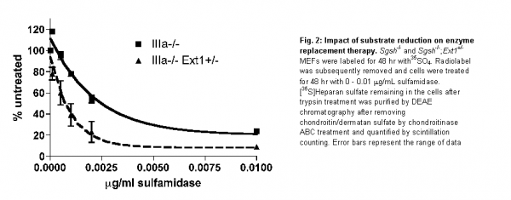

In summary, we are approaching completion of both aims of the grant. Substrate reduction therapy has been demonstrated ex vivo using siRNA and gene knock out of Ext1 and in vivo studies are underway. In addition to the studies outlined above, funds provided by this grant has allowed us to successfully characterize secondary accumulation of dermatan sulfate in Sanfilippo fibroblasts (Lamanna et al.,J. Biol. Chem. 2011). To determine the impact of secondary dermatan sulfate storage on disease pathology, we are characterizing dermatan sulfate levels in different organs ofSgsh^{-/-} mice as well as the sensitivity of secondary storage to enzyme replacement therapy.
We would like to thank the National MPS Society for this funding opportunity.

MPS III
Dr. Alessandro Fraldi
TIGEM, Naples, Italy
Developing a systemic AAV-mediated gene therapy approach to cross the blood-brain barrier and treat CNS pathology in Mucopolysaccharidosis type IIIA
Cellular trafficking of the chimeric sulfamidase enzymes
Understanding the cellular trafficking of the chimeric sulfamidase enzymes (containing the alternative signal peptide and the ApoB LDLR-BD) is critical to evaluate the clinical efficacy of the engineered sulfamidase and to correctly interpret the results we will obtain from thein vivo studies. We analyzed the capability of the chimeric sulfamidase enzymes to correctly localize with lysosomal compartment in transfected cells and in cells receiving the enzyme upon uptake. The flag tag was replaced with a myc tag, which give more reliable and specific signal in immunofluorescence analysis. The IDSsp-SGSHmyc-ApoB and hAATsp-SGSHmyc-ApoB along with partial modified sulfamidase enzymes (containing only the alternative signal peptides: IDSsp-SGSHmyc and hAATsp-SGSHmyc) and not-modified sulfamidase (SGSHmyc) were transfected in MPS-IIIA MEFs. Immunostaining with anti-myc and anti-LAMP1 antibodies showed a lysosomal localization for both partial and final engineered constructs similar to that observed in cells transfected with not-modified sulfamidase (Fig. 1).
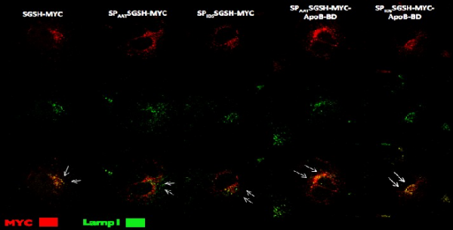
Figure 1. MPS-IIIAMEFcells weretransfectedwith either partial or final engineered constructs or with control not-modifiedSGSHconstruct. All thecontructscontained amyctag. The chimeric constructs display alysosomallocalization as showed byimmunostainingwithanti-mycandanti-LAMP1antibodies.
We then analyzed the capability of chimeric sulfamidase enzyme to be uptaken from MPS-IIIA cells and re-localize to lysosomal compartment. HepG2 cells were transfected with IDSsp-SGSHmyc-ApoB, hAATsp-SGSHmyc-ApoB along with partial modified sulfamidase enzymes (IDSsp-SGSHmyc and hAATsp-SGSHmyc) and non-modified sulfamidase (SGSHmyc). MPS-IIIA MEFs were then incubated with the conditioned medium derived from each transfection. The sulfamidase activity and the subcellular localization of both chimeric and not-modified sulfamidase enzymes were then evaluated in MPS-IIIA MEFs. As shown in figure 2 all the chimeric sulfamidase enzymes display a specific activity in the recipient MPS-IIIA MEF cells thus demonstrating the capability of the chimeric enzymes to be efficiently uptaken (Figure 2). In addition, the chimeric enzymes were also able to correctly re-localize to the lysosomal compartment upon be uptaken (Figure 3).

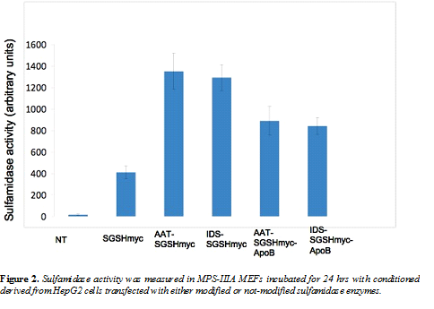

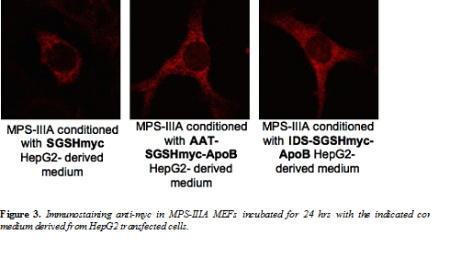

In vivo large study in MPS-IIIA mice
We expanded the MPS-IIIA colony and have obtained a large number of mice to be used in thein vivo large study.
We systemically injected one-month old MPS-IIIA mice with AAV2/8-TBG vectors harboring cDNAs encoding either AATsp or IDSsp N-terminal-modified sulfamidase enzymes containing the ApoB-LDLR-BD at their C-terminal (AATsp-SGSH-myc-ApoB-BD and IDSsp-SGSH-myc-ApoB-BD). Control mice have been injected with AAV2/8 expressing either the not-modified sulfamidase enzyme (SGSHmyc) or the partially modified sulfamidase enzymes (only containing the signal peptide replacement; AATsp-SGSH-myc and IDSsp-SGSH-myc).
We established three different time points after injections for the evaluation of CNS phenotype rescue (1 month, 3 months and 7 months). We sacrificed the mice corresponding to the first two time points (1 month and 3 months post-injection). These mice are under evaluation for CNS transduction (enzyme activity into the brain) and CNS pathology (storage, autophagy and inflammation).
We obtained very important results by measuring the sulfamidase enzyme activities into the brain of MPS-IIIA mice 3 months post-injection. A stronger sulfamidase activity was observed in the brain of MPS-IIIA mice injected with AAV2/8 encoding the modified sulfamidase enzyme AATsp-SGSH-myc-ApoB-BD when compared to the sulfamidase activity observed in the brain of MPS-IIIA mice injected with not-modified sulfamidase (SGSH-myc) (Figure 4). Moreover, the sulfamidase activity in the brain of MPS-IIIA injected with the modified sulfamidase was also associated to the presence of the enzyme into the brain of injected mice as shown by immunostaining anti-myc (Figure 5). We are now completing the analysis of the first two groups of injected mice corresponding to 1 month and 3 months post-injection (CNS transduction and CNS pathology).The mice a 7 months post-injection will be assessed for behavioural phenotype at the end of September 2011.
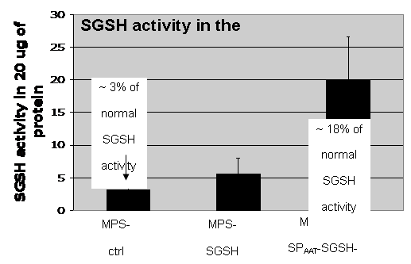
Figure 4.SGSHactivity was measured in the brain ofMPS-IIIAmice systemically injected withAAV2/8-TBG-hAATsp-SGSHmyc-ApoBorAAV2/8-TBG-SGSHmyc. The activity in control not- injectedMPS-IIIAbrain was also displayed.

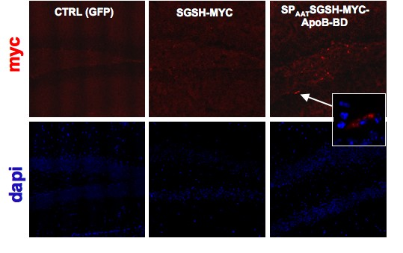
Figure 5.Immunostaining anti-myc in the hippocampus of MPS-IIIA mice systemically injected with either AAV2/8-TBG-hAATsp-SGSHmyc-ApoB or AAV2/8-TBG-SGSHmyc. Control MPS-IIIA hippocampus was also displayed.
General
Dr. Calogera M. Simonaro
Mount Sinai School of Medicine, New York, NY
Novel Anti-Inflammatory Therapies For The Mucopolysaccharidoses
Although enzyme replacement therapy (ERT) is currently available for three MPS diseases and under development for others, the effects of this therapy on bone and cartilage are very limited. Thus, new approaches are clearly needed to more effectively treat MPS patients, alone or as adjuncts to ERT.
In this research project we comprehensively evaluated the bones and joints of MPS VI rats treated by anti-inflammatory therapy (i.e., anti-TNF-alpha therapy), alone and in combination with ERT. Several anti TNF-alpha drugs (e.g., Remicade, Embrel) are currently used clinically for the treatment of arthritis, inflammatory bowel disease and others common diseases, and the underlying premise of our work is that if these drugs proved effective in MPS animal models, they could potentially be fast-tracked into clinical use for MPS patients. Our previous work also has shown that the anti TNF-alpha inflammatory pathway is activated in many MPS animal models and patients (i.e., the toll-like receptor 4, TLR4, pathway), providing the scientific rationale for this approach.
In our first set of experiments we completed a proof-of-principle experiment in which the TNF-alpha inflammatory pathway (i.e., Toll-like receptor 4 pathway) was inactivated in mice with MPS VII. We found that when this pathway was inactivated from the earliest stages of development, there was a significant improvement in the bone length, bone growth plates, and joint pathology of the MPS VII animals. The paper reporting these findings was published in the Proceedings of the National Academy of Sciences in 2010.
We next turned to experiments evaluating anti TNF-alpha therapy in MPS VI rats, alone and in combination with ERT. In adult MPS VI rats that were treated by anti-TNF-alpha therapy, we found that the circulating levels of many inflammatory molecules in the blood were substantially reduced. Surprisingly, ERT alone also substantially reduced the circulating levels of these inflammatory markers, supporting the concept that the inflammatory pathways in MPS are directly activated by glycosaminoglycan (GAG) storage. We hypothesize that the reduction of circulating inflammatory makers by ERT reflects the delivery and function of the enzyme in readily assessable organs in the MPS animals, such as the liver, spleen, etc.
Animals treated by ERT or anti TNF-alpha therapy alone did not exhibit any significant improvement in bone growth. However, the articular (joint) cartilage of animals receiving anti-TNF-alpha therapy had fewer dying (apoptotic) cells, in contrast to animals receiving ERT that were similar to untreated MPS animals. Importantly, when the two treatments were combined, notable clinical and other improvements were observed. MPS VI rats receiving combined treated exhibited a more normal gait and could remain longer on a rotorod apparatus better than animals receiving either anti TNF-alpha or ERT. Their bones were also slightly longer, and there was much less evidence of inflammation in the joints (e.g., synovial tissue hyperplasia). Perhaps most impressively (and unexpectedly), animals receiving combined treatment had markedly less deformed tracheas, with thinner tracheal walls and wider open spaces. The results of these studies have been summarized in a manuscript that is currently in review.
In conclusion, these animal models studies have suggested that combining anti TNF-alpha therapy with ERT may provide substantial clinical benefits to MPS patients. In addition to a direct effect on inflammation, these therapies could also reduce immune responses against the recombinant enzymes, and improve the accessibility of the enzymes to pathologic sites in vivo. Future studies are planned in the dog and cat models of MPS, and using different anti-inflammatory therapies.

